**Godavari College Of Engineering, Jalgaon.**

**Subject Name:** PDE **Teacher Name:** Prof.Nilesh Chaudhari sir.

**Practical No**. : 1 **Date:**

**Class: S**.E **Roll No: 1951711245011**

**Title:**  Explaining Use Case Diagram in Software Engineering.

**Use Case Diagram :-** A use case diagram at its simplest is a representation of a user's interaction with the system that shows the relationship between the user and the different use cases in which the user is involved. A use case diagram can identify the different types of users of a system and the different use cases and will often be accompanied by other types of diagrams as well. The use cases are represented by either circles or ellipses.

A use case diagram is usually simple. It does not show the detail of the use cases:

• It only summarizes some of the relationships between use cases, actors, and systems.

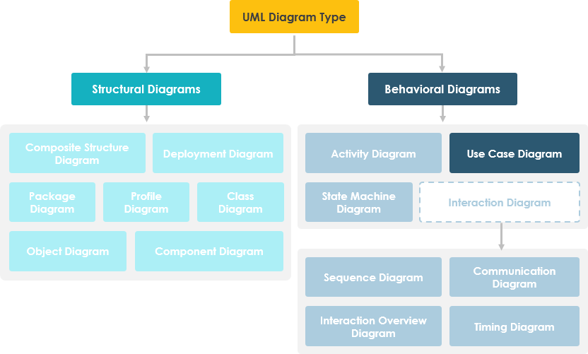 • It does not show the order in which steps are performed to achieve the goals of each use case.

**Use Cases :-** In software and system engineering , a use case is a list of actions or event steps typically defining the interactions between a role (known in the Unified Modeling Language (UML) as an actor) and a system to achieve a goal.

**Purpose of Use Case Diagrams**

The purpose of use case diagram is to capture the dynamic aspect of a system. However, this definition is too generic to describe the purpose, as other four diagrams (activity, sequence, collaboration, and Statechart) also have the same purpose. We will look into some specific purpose, which will distinguish it from other four diagrams.

In brief, the purposes of use case diagrams can be said to be as follows −

• Capture the requirements of a system.

• Used to get an outside view of a system.

• Identify the external and internal factors influencing the system.

• Show the interaction among the requirements are actors.

• Specify the system context.

• Validate a systems architecture

• Developed by analysts together with domain experts

**How to Draw a Use Case Diagram ?**

Use case diagrams are considered for high level requirement analysis of a system. When the requirements of a system are analyzed, the functionalities are captured in use cases.

We can say that use cases are nothing but the system functionalities written in an organized manner. The second thing which is relevant to use cases are the actors. Actors can be defined as something that interacts with the system.

Actors can be a human user, some internal applications, or may be some external applications. When we are planning to draw a use case diagram, we should have the following items identified.

• Functionalities to be represented as use case

• Actors

• Relationships among the use cases and actors.

**Use case diagrams can be used for −**

• Requirement analysis and high level design.

• Model the context of a system.

• Reverse engineering.

• Forward engineering.

**Use Case Diagram at a Glance :-**

A standard form of use case diagram is defined in the Unified Modeling Language as shown in the Use Case Diagram example below:

|  |  |
| --- | --- |
| Notation Description | Visual Representation |
| Actor   * Someone interacts with use case (system function). * Named by noun. * Actor plays a role in the business * Similar to the concept of user, but a user can play different roles * For example:   + A prof. can be instructor and also researcher   + plays 2 roles with two systems * Actor triggers use case(s). * Actor has a responsibility toward the system (inputs), and Actor has expectations from the system (outputs). |  |
| Use Case   * System function (process - automated or manual) * Named by verb + Noun (or Noun Phrase). * i.e. Do something * Each Actor must be linked to a use case, while some use cases may not be linked to actors. |  |
| Communication Link   * The participation of an actor in a use case is shown by connecting an actor to a use case by a solid link. * Actors may be connected to use cases by associations, indicating that the actor and the use case communicate with one another using messages. |  |
| Boundary of system   * The system boundary is potentially the entire system as defined in the requirements document. * For large and complex systems, each module may be the system boundary. * For example, for an ERP system for an organization, each of the modules such as personnel, payroll, accounting, etc. * can form a system boundary for use cases specific to each of these business functions. |  |

**Use Case Example - Association Link**

A Use Case diagram illustrates a set of use cases for a system, i.e. the actors and the relationships between the actors and use cases.

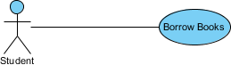

**Use Case Example - Include Relationship**

The include relationship adds additional functionality not specified in the base use case. The <<Include>> relationship is used to include common behavior from an included use case into a base use case in order to support the reuse of common behavior.

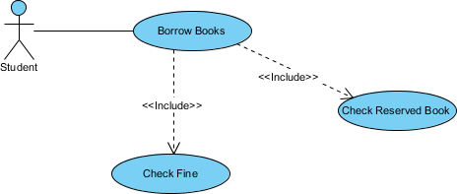

**Use Case Example - Extend Relationship**

The extend relationships are important because they show optional functionality or system behavior. The <<extend>> relationship is used to include optional behavior from an extending use case in an extended use case. Take a look at the use case diagram example below. It shows an extend connector and an extension point "Search".

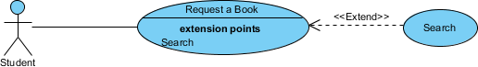

**Use Case Example - Generalization Relationship**

A generalization relationship means that a child use case inherits the behavior and meaning of the parent use case. The child may add or override the behavior of the parent. The figure below provides a use case example by showing two generalization connectors that connect between the three use cases.

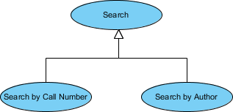

**Conclusion:-**  In this assignment i learn what is Use Case Diagram and How to implement it.